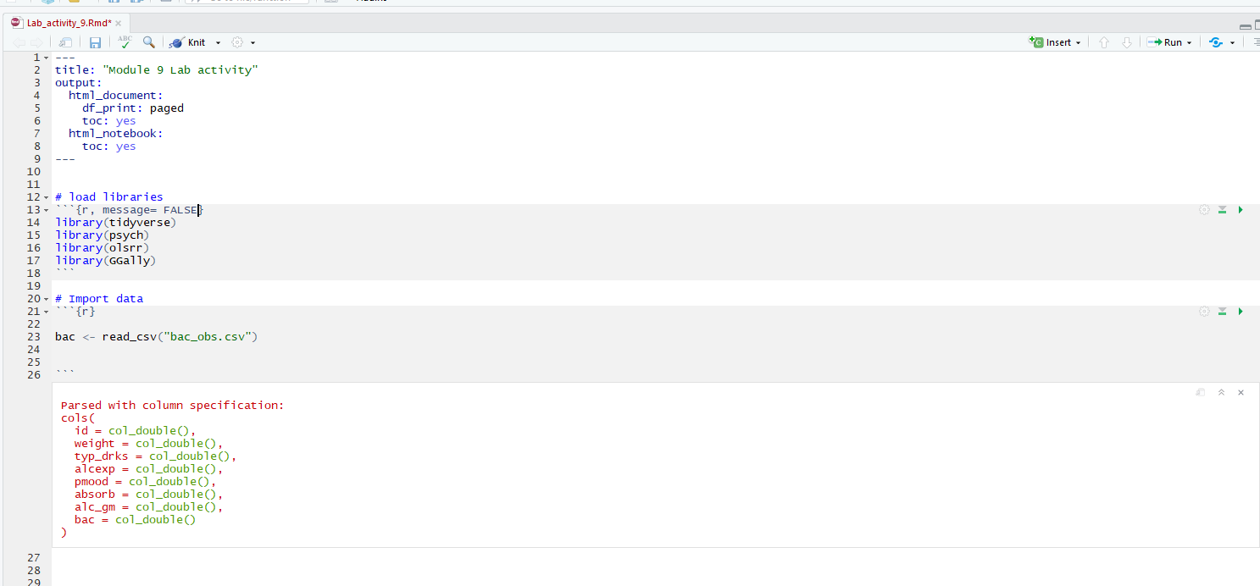

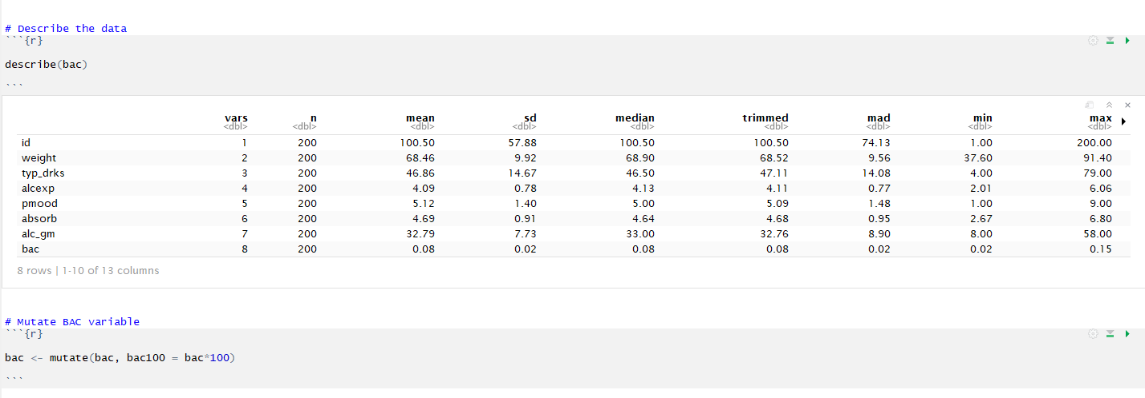

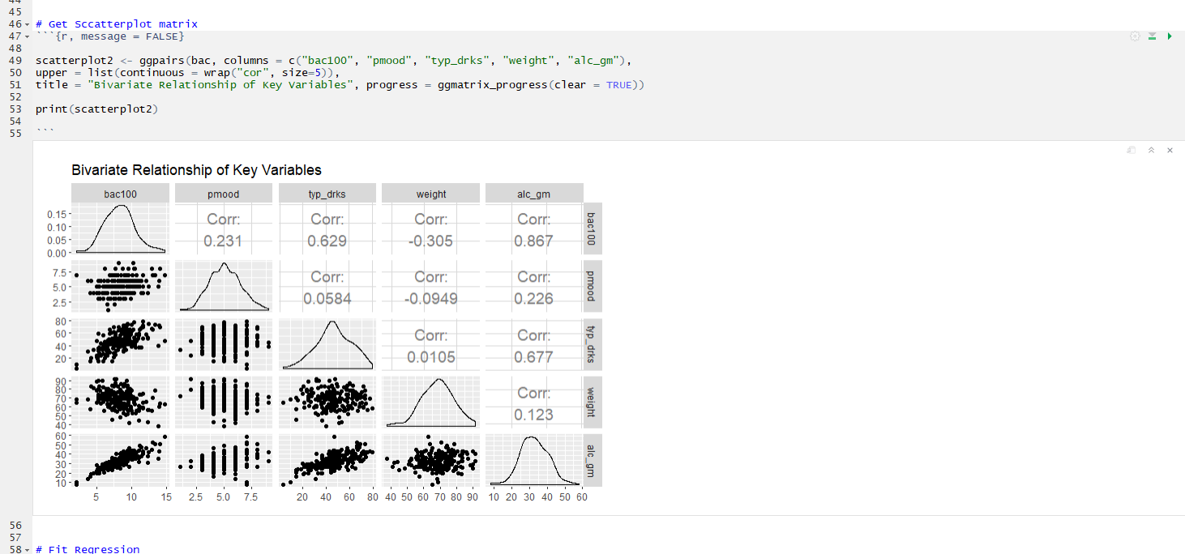

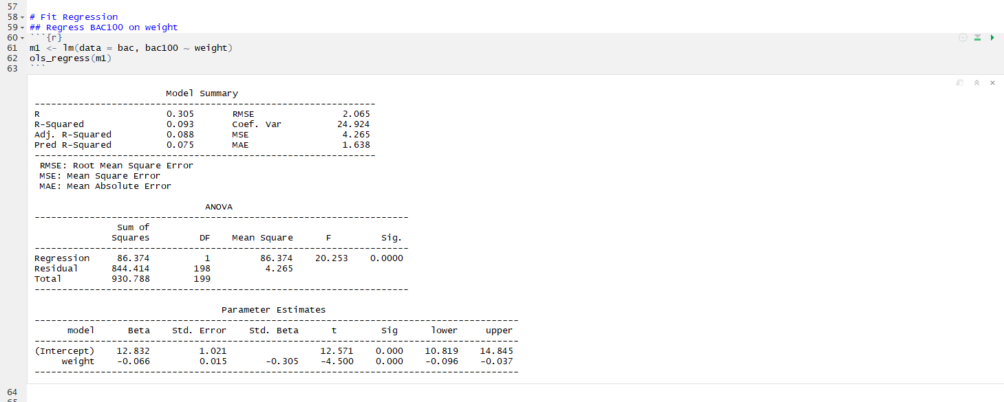

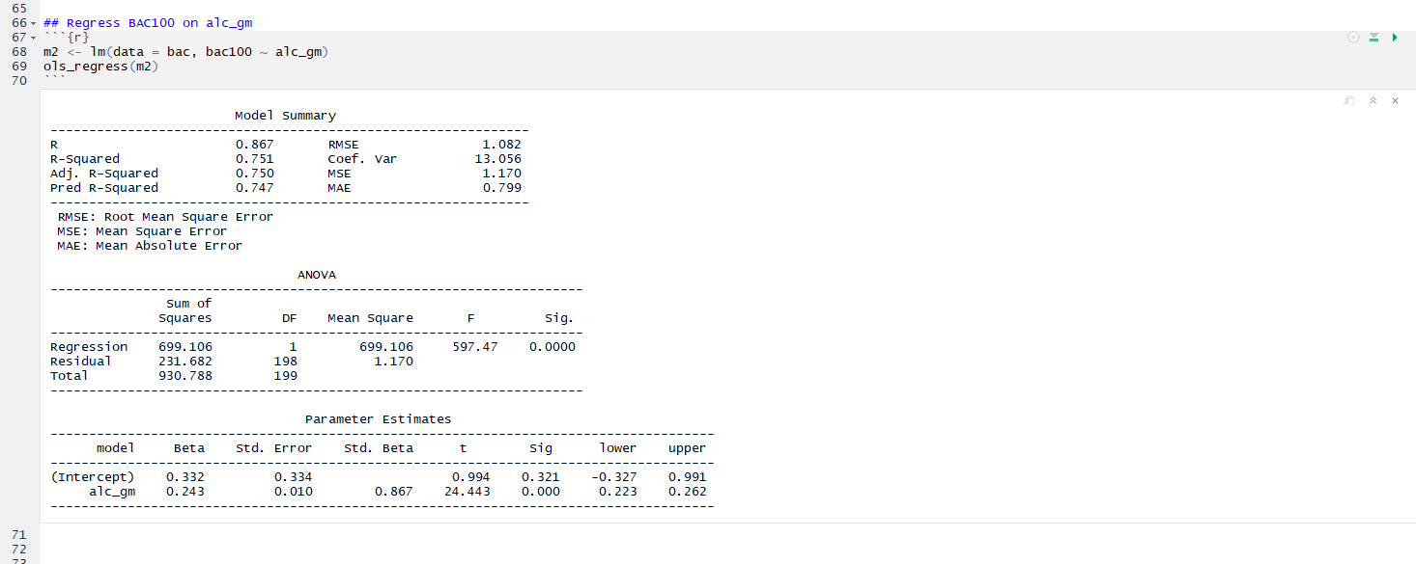

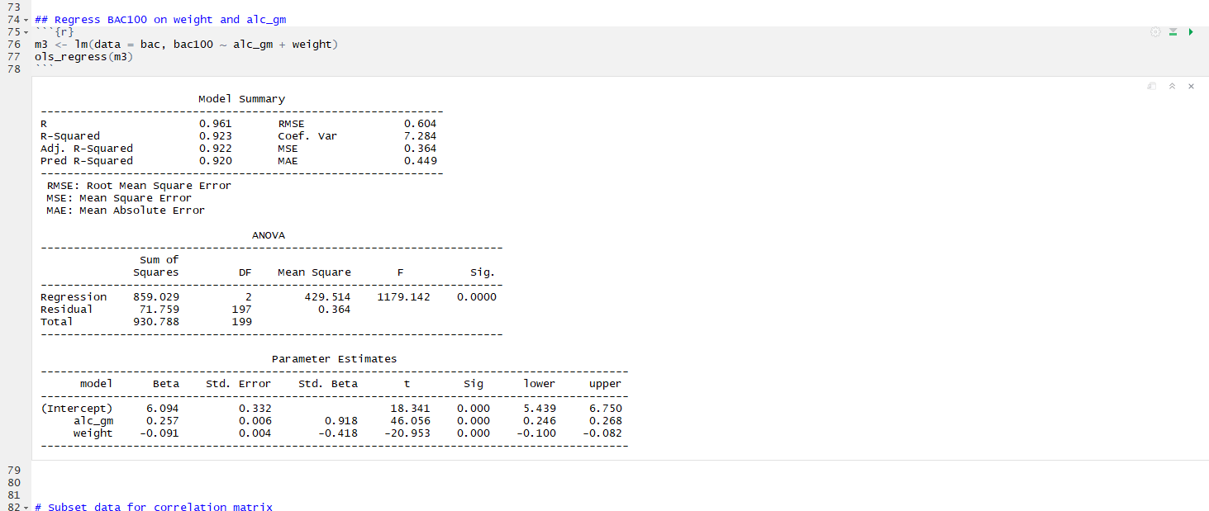

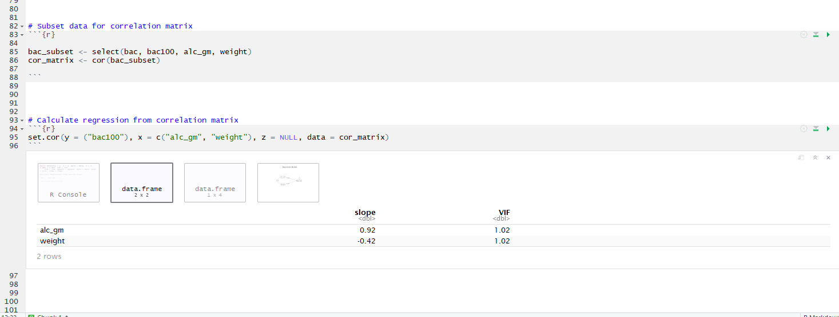

The Slope values for alc_gm & weight are equivalent to the standardized slopes in our regression model above.

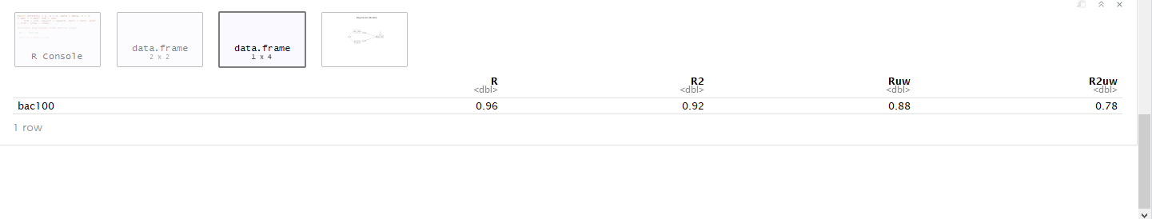

The R and R^2 values are equivalent to the multiple regression model with the exact same parameters specified.

This method may be preferrable if you need to weight one variable more than the other. MLR uses optimal weights to reduce the squared errors as much as possible. However, if you, as the researcher, know that alc_gm should be weighted differently, then you would need to use the correlation matrix and perform matrix algebra to weight them appropriately.